

**Lieshan valliadum**

**ST10439494**

**Introduction to mobile application development**

**Assesment type: Practicum Exam**



Table of Contents

**Purpose and explanation of the app:** 2

**Pseudocode and flowcharts** 3

# **Purpose and explanation of the app:**

The main purpose and use of this app is to provide detailed information related to the weather on each day. The app is required to manage the weather conditions and examine the conditions too. The app can be very beneficial to its users because of the following.

By the users knowing what kind of weather is expected in the day, it allows them to plan ahead and make the necessary arrangements that they need for they day to be successful. People will be able to know what activities they can and cannot take part in and whether they are required to stay indoors or not.

The app will also be able to ensure safety as citizens will be able to prepare themselves for any natural disasters such as floods or hurricanes. People will know whether they can go out or not or whether they are needed to evacuate the area in order to survive.

Environmental awareness will also be promoted. By using a weather app, people will become more and more aware of the environment. Weather patterns and change in temperature can all be studied and analysed by the use of a weather app.

This app was designed to provide a deep, descriptive insight on weather conditions through the week. This app does indeed serve this purpose.

# **Pseudocode and flowcharts**

SplashActivity

**onCreate**

Set the content view to activity_splash.xml

Start a handler to delay for 3 seconds

After 3 seconds, start MainActivity and finish SplashActivity

MainActivity

**onCreate**

Set the content view to activity_main.xml

Initialize an array of temperatures (min, max) for each day of the week

Calculate the average temperature using a helper function

Display the average temperature in avgTempTextView

Set up a button click listener to navigate to DetailedViewActivity

Set up a button click listener to clear user data

**calculateAverageTemperature**

Initialize totalMinTemp and totalMaxTemp to 0

Loop through each temperature pair, summing min and max values

Return the average temperature by dividing the total by the number of days

DetailedViewActivity

**onCreate**

Set the content view to activity_detailed_view.xml

Enable the back button in the action bar

Initialize arrays for days of the week, temperatures, and weather conditions

Create a list of weather details for each day

Set up an adapter to display the weather details in a ListView

**onOptionsItemSelected**

If the back button in the action bar is clicked, finish the activity to return to the previous screen

XML Layout Files

**activity_splash.xml**

Define a RelativeLayout with an ImageView for the logo and a TextView for the app name

**activity_main.xml**

Define a RelativeLayout with a TextView for the average temperature and buttons for viewing details and clearing data

**activity_detailed_view.xml**

Define a RelativeLayout with a ListView for displaying detailed weather information

AndroidManifest.xml

Declare SplashActivity, MainActivity, and DetailedViewActivity

Set SplashActivity as the launcher activity

Specify MainActivity as the parent activity for DetailedViewActivity for proper back navigation

# **Screenshots of each screen**

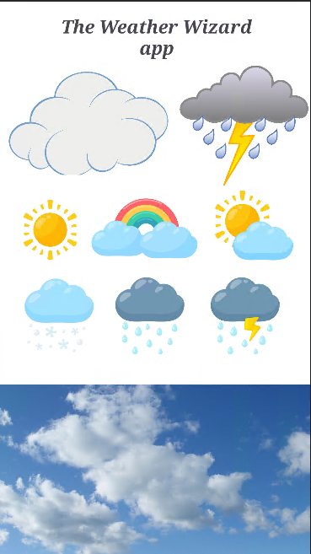

Figure 1: Splash screen UI

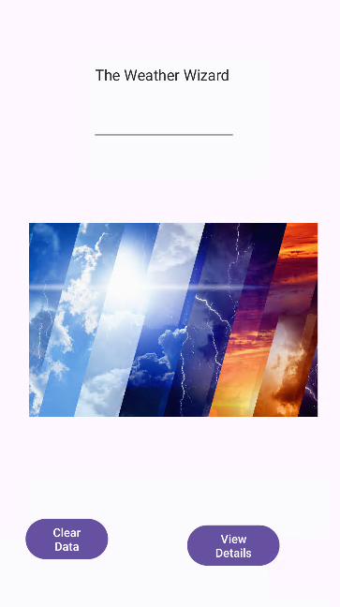

Figure 2: Main activity ui